SIMATS ENGINEERING
ASSESSMENT TOOL 2

COURSE NAME: COMPUTER NETWORKS
COURSE CODE: CSA07

COURSE OUTCOME COVERED
CO4:
Design network topologies star, mesh, bus, and hybrid using networking devices, transmission media, and cabling standards
(BL2,BL6)
Assessment Tool Weightage: 30%

Annexure A
Industry Problem Solving Task

Code of Conduct:
I A SREENATH(192525119) certify that this submission is my original work
and that I have adhered to the guidelines specified for this assessment.
I understand that any violation of academic integrity rules will result in disciplinary action.
Signature of the student: A SREENATH

- A star topology is ideal for a 20-person startup because all devices connect to a central switch, making the network easy to manage and troubleshoot. At the core sits a Layer 2/Layer 3 managed switch (such as a Cisco Catalyst or Netgear ProSafe) with at least 24 ports to accommodate all workstations, printers, and VoIP phones with room to grow. Each device connects to the switch using Cat6 UTP cables, which support Gigabit speeds up to 100 meters — more than sufficient for any typical office floor plan. The switch uplinks to a router/firewall (such as a Cisco RV series or pfSense appliance) that handles internet access, DHCP, and network address translation. A Wi-Fi access point connected to the switch extends wireless coverage for laptops and mobile devices. The key advantage of this design is fault isolation: if one workstation&#39;s cable fails, only that single node goes offline, leaving all other 19 employees unaffected. Centralised cable management also simplifies future moves, adds, and changes.
Sol:
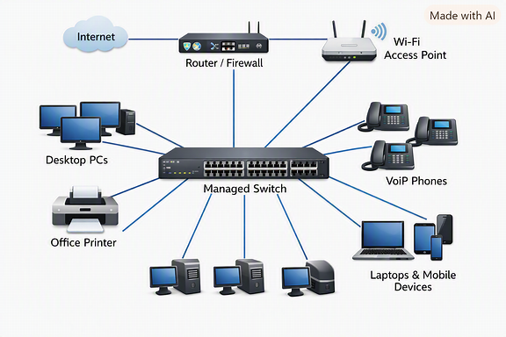

- Centralized control: A managed Layer 2/3 switch at the core means you can segment traffic with VLANs, apply QoS for VoIP, and monitor everything from one point.
- Scalability: With a 24-port switch, you’ve got headroom for growth without needing immediate upgrades.
- Fault isolation: As you noted, a single cable or NIC failure only affects one device, not the whole network.
- Performance: Cat6 cabling ensures Gigabit throughput, which is more than enough for typical office workloads.
- Security & routing: The router/firewall handles DHCP, NAT, and internet access, keeping the switch focused on LAN traffic.
- Wireless extension: Adding an AP gives flexibility for mobile devices without complicating the wired backbone.
Things to keep in mind
- Redundancy: Consider dual uplinks or a secondary switch if uptime is critical. A single switch is a single point of failure.
- PoE (Power over Ethernet): If you plan to use VoIP phones or APs, a PoE-capable switch saves you from extra power adapters.
- Monitoring: Enable SNMP or NetFlow on the switch/router for visibility into traffic patterns.
- Future growth: If you expect to expand beyond 24 devices quickly, stacking switches or planning for a 48-port model might be wise.

2. A bank demands near-zero downtime, making a full or partial mesh topology the right choice. In a full mesh, every core network device — routers, core switches, and servers — connects directly to every other device, so no single link or node failure can bring down the network. For a bank, a partial mesh is typically deployed at the core layer (connecting all core switches and firewalls to each other) while the distribution and access layers use redundant uplinks to at least two core switches. Dual enterprise-grade routers (such as Cisco ASR or Juniper MX series) provide BGP-based redundant internet connectivity. All links between core devices use fiber optic cables — either single-mode for long distances between buildings or multi-mode OM4 within the data center — because fiber is immune to electromagnetic interference, supports very high bandwidth, and is essential for maintaining low-latency financial transactions. Redundant power supplies, UPS systems, and RAID storage arrays further complement the mesh design. The justification is straightforward: when a link fails in a mesh, traffic automatically reroutes through alternative paths in milliseconds using protocols like OSPF or BGP, satisfying regulatory requirements for uptime and data integrity.
Sol:
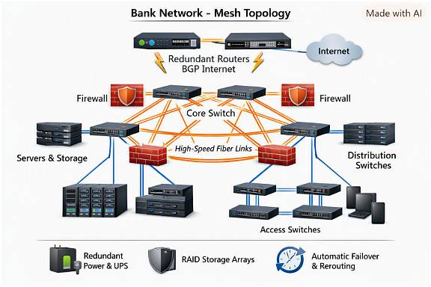

Mesh Topology for Banking Networks
🔹 1. Purpose and Need
- Banks require near-zero downtime to ensure continuous financial operations.
- High availability and fault tolerance are essential for regulatory compliance and data integrity.
🔹 2. Topology Type
- Full Mesh: Every device connects directly to every other device — ideal for maximum redundancy.
- Partial Mesh: Common in banks; only core devices (switches, routers, firewalls) are fully interconnected, while other layers have redundant uplinks.
🔹 3. Core Network Design
- Core Layer: Interconnected core switches and firewalls using fiber optic links.
- Distribution Layer: Connects to multiple core switches for redundancy.
- Access Layer: End devices connect via dual uplinks to distribution switches.
🔹 4. Hardware Components
- Routers: Dual enterprise-grade routers (e.g., Cisco ASR, Juniper MX) for BGP-based internet redundancy.
- Switches: High-performance managed switches with redundant power supplies.
- Firewalls: Deployed in pairs for failover protection.
- Servers & Storage: RAID arrays ensure data reliability and fast recovery.
🔹 5. Cabling and Connectivity
- Fiber Optic Links:
  - Single-mode fiber for long-distance inter-building connections.
  - Multi-mode OM4 fiber for short-range, high-speed data center links.
- Fiber ensures high bandwidth, low latency, and immunity to interference.
🔹 6. Redundancy and Reliability
- Dual paths between devices prevent single points of failure.
- UPS systems and redundant power supplies maintain uptime during outages.
- Automatic failover reroutes traffic instantly using OSPF or BGP protocols.
🔹 7. Advantages
- High availability: No single failure disrupts the network.
- Fast recovery: Traffic reroutes within milliseconds.
- Regulatory compliance: Meets uptime and integrity standards.
- Scalability: Supports future expansion without redesign.

3. For a small classroom lab with a tight budget, bus topology offers the lowest hardware cost because all computers share a single common communication line — the bus — eliminating the need for a central switch or hub. A single coaxial cable (RG-58, 50-ohm) or, in a modern variation, a single Cat5e/Cat6 cable daisy- chained through an inexpensive unmanaged hub runs along the length of the room. Each computer connects to the backbone using a T-connector and a BNC connector in a classic coaxial setup, with terminators (50-ohm) placed at both ends of the cable to absorb signals and prevent reflection. For a more contemporary low-cost implementation, a single inexpensive 8- or 16-port unmanaged switch replaces the terminators and uses Cat5e UTP patch cables to each workstation — achieving bus-like simplicity at minimal cost. The primary limitation is that the network is susceptible to collisions and a single cable break disrupts all connected machines, but for a supervised classroom environment with light usage (internet browsing, file sharing), this trade-off is entirely acceptable. No dedicated server is required; a teacher&#39;s PC can share resources using built-in Windows/Linux file sharing.
Sol:
Bus Topology for a Small Classroom Lab
🔹 1. Purpose and Suitability
- Designed for small networks with limited users and budget constraints.
- Ideal for classroom labs where cost efficiency outweighs performance needs.
- Simple to install and maintain — perfect for educational setups.
🔹 2. Topology Structure
- All computers share a single communication line (the bus).
- Data travels along this backbone, and each device listens for messages addressed to it.
- No central switch or hub is required, reducing hardware costs.
🔹 3. Cabling and Connectors
- Classic setup: Uses coaxial cable (RG-58, 50-ohm) with T-connectors and BNC connectors.
- Modern variation: Uses Cat5e/Cat6 UTP cables daisy-chained through an unmanaged hub or switch.
- Terminators (50-ohm) are placed at both ends of the coaxial cable to prevent signal reflection.
🔹 4. Hardware Requirements
- Minimal equipment: PCs, coaxial cable or Cat5e/Cat6, connectors, and terminators.
- Optional unmanaged switch (8- or 16-port) for simplified modern implementation.
- No dedicated server — a teacher’s PC can act as a file/resource server using built-in OS sharing tools.
🔹 5. Advantages
- Low cost: Least expensive topology — minimal cabling and hardware.
- Easy setup: Simple linear layout, quick to install.
- Sufficient for light usage: Works well for browsing, file sharing, and basic classroom tasks.
🔹 6. Limitations
- Single point of failure: A cable break disrupts the entire network.
- Collision-prone: Shared medium can cause data collisions under heavy load.
- Limited scalability: Adding more devices increases collision risk and slows performance.
- Troubleshooting difficulty: Faults can be hard to isolate along the shared cable.
🔹 7. Use Case Justification
- In a supervised classroom, where usage is light and controlled, these drawbacks are manageable.
- Offers a cost-effective learning environment for networking basics.

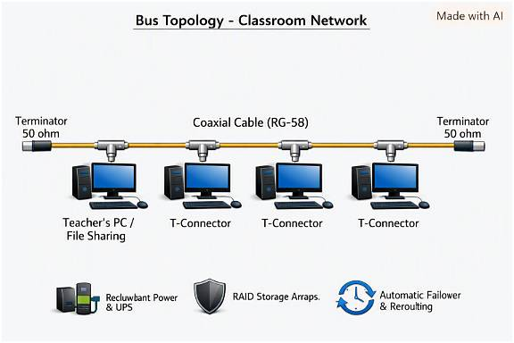
4. A large university campus serves thousands of users across multiple buildings — lecture halls, labs, libraries, dormitories, and administration — making a single topology inadequate. A hybrid topology combines the best elements of multiple designs: a fiber-based ring or mesh at the campus backbone level for redundancy, a star topology within each building for manageability, and bus or tree structures within individual labs for cost- efficiency. At the campus core, high-speed fiber optic cables (single-mode, 10 Gbps or 40 Gbps) interconnect core routers and multilayer switches using a ring or partial mesh arrangement, ensuring that no single link failure isolates an entire building. Each building has its own distribution switch connected to the campus core via dual fiber uplinks. Within each building, a traditional star topology branches from the distribution switch to floor-level access switches, which then connect individual devices via Cat6 cables. This hierarchical three- layer model — core, distribution, and access — is the industry standard for enterprise and campus networks because adding a new building simply means installing a new distribution switch and running fiber to the core, with no disruption to existing infrastructure. Wireless access points throughout the campus connect via PoE (Power over Ethernet) to access switches, eliminating the need for separate power cabling. The hybrid design thus delivers redundancy at the backbone, simplicity at the building level, and scalability campus-wide.
Sol:
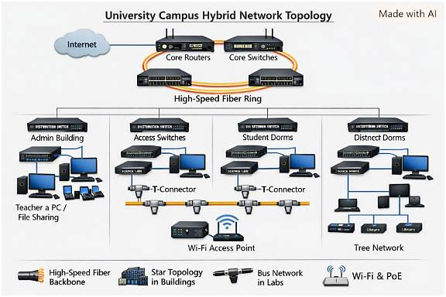
Hybrid Topology for a University Campus
🔹 1. Purpose and Need
- A large university must support thousands of users across multiple buildings.
- A single topology cannot meet all requirements — hence a hybrid design combining multiple topologies.
- Ensures redundancy, scalability, and manageability across the entire campus.
🔹 2. Core Concept
- Combines ring/mesh, star, and bus/tree topologies.
- Each layer of the network uses the topology best suited for its function:
  - Campus backbone: Ring or partial mesh for redundancy.
  - Building networks: Star topology for easy management.
  - Labs/classrooms: Bus or tree topology for cost efficiency.
🔹 3. Campus Backbone (Core Layer)
- Fiber-based ring or mesh interconnects core routers and multilayer switches.
- Uses single-mode fiber for long distances and multi-mode OM4 fiber within data centers.
- Speeds of 10 Gbps to 40 Gbps ensure high performance.
- Redundant links prevent isolation — if one link fails, traffic reroutes automatically.
🔹 4. Building Networks (Distribution Layer)
- Each building has a distribution switch connected to the campus core via dual fiber uplinks.
- Provides fault tolerance and load balancing.
- Acts as the intermediary between the core and access layers.
🔹 5. Floor-Level Networks (Access Layer)
- Star topology connects access switches to end devices (PCs, printers, APs).
- Cat6 UTP cables provide Gigabit connectivity within floors.
- Wireless Access Points (APs) connect via PoE (Power over Ethernet) — no separate power lines needed.
🔹 6. Scalability and Expansion
- Adding a new building only requires installing a new distribution switch and running fiber to the core.
- No disruption to existing infrastructure — supports modular growth.
🔹 7. Advantages
- Redundancy: Ring/mesh backbone ensures continuous connectivity.
- Manageability: Star topology simplifies troubleshooting within buildings.
- Cost efficiency: Bus/tree structures reduce hardware costs in labs.
- Scalability: Easy to expand campus-wide without redesign.
- Performance: Fiber backbone supports high-speed data transfer for research and administration.

5. Designing a network for a company with multiple departments involves creating a structured and scalable architecture using switches and routers to ensure efficient communication and security. Each department (such as HR, Finance, Sales, and IT) is connected through dedicated Layer 2 switches that form the access layer, allowing devices like computers and printers to communicate within the same department. These switches are then connected to a central Layer 3 switch or router, which acts as the core layer and enables communication between different departments through inter-VLAN routing. Virtual LANs (VLANs) are configured to logically separate each department’s network, improving security and reducing broadcast traffic. A router is also used to connect the internal network to external networks such as the internet, often with firewall functionality for security. Redundant links and backup paths can be included to ensure reliability, while proper IP addressing and subnetting are applied for efficient network management. This hierarchical design improves performance, enhances security, and allows easy expansion as the company grows.
Sol:

Network Design for a Multi-Department Company
🔹 1. Purpose and Objective
- To create a structured, scalable, and secure network architecture.
- Ensures efficient communication between departments and controlled access to shared resources.
🔹 2. Hierarchical Architecture
- Follows a three-layer model:
  - Access Layer: Departmental switches connecting end devices.
  - Core Layer: Central router or Layer-3 switch enabling inter-department communication.
  - Edge Layer: Router/firewall connecting the internal network to the internet.
🔹 3. Departmental Segmentation
- Each department (HR, Finance, Sales, IT, etc.) has its own Layer-2 switch.
- Devices like PCs, printers, and VoIP phones connect to these switches.
- VLANs are configured to logically separate departments — improving security and reducing broadcast traffic.
🔹 4. Core Connectivity
- All departmental switches connect to a central Layer-3 switch or router.
- Inter-VLAN routing allows communication between departments while maintaining isolation.
- The router also connects to the firewall and internet gateway.
🔹 5. Security Measures
- Firewalls protect against external threats.
- Access Control Lists (ACLs) restrict inter-department traffic based on policies.
- VLAN segmentation prevents unauthorized access to sensitive data.
🔹 6. Reliability and Redundancy
- Redundant links between switches and routers ensure uptime.
- Backup paths and failover configurations maintain connectivity during hardware failures.
- Spanning Tree Protocol (STP) prevents loops in Layer-2 networks.
🔹 7. IP Addressing and Subnetting
- Each department receives a unique subnet (e.g., HR: 192.168.10.0/26, Finance: 192.168.10.64/26).
- Simplifies management and troubleshooting.
- Enables efficient routing and bandwidth utilization.
🔹 8. Scalability
- New departments can be added easily by creating new VLANs and connecting additional switches.
- The hierarchical design supports growth without redesigning the entire network.
🔹 9. Advantages
- Performance: Reduced broadcast traffic and optimized routing.
- Security: Logical isolation between departments.
- Manageability: Clear structure simplifies administration.
- Scalability: Easy expansion as the company grows.

